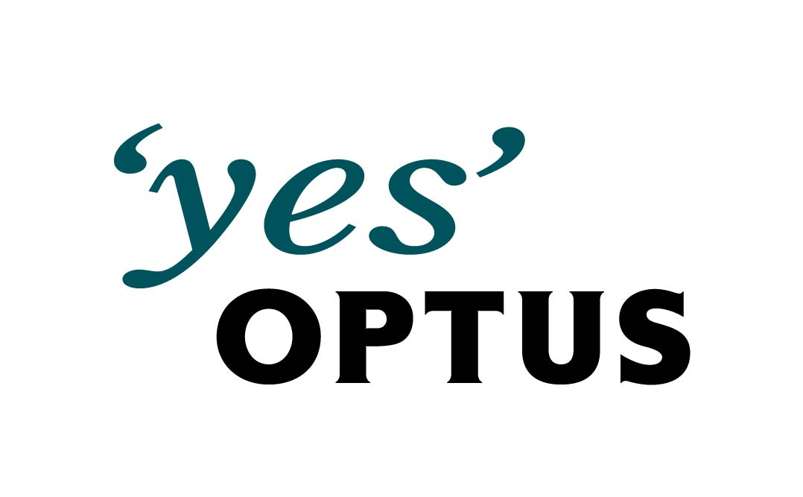 | Optus Enterprise Networks  Engineering Work Order (EWO)  OEN Implementation Work-Plan  EWO Plan Version 1.0

Description of the Change  Single line description of change | New load balancing configuration for GSB non-prod servers
OEN Project or Case No:
CARS No:

BORIS EO No:

PTW No: & Type
Phone, Advice, Hazard of Outage
Network Domain  Eg: Admin, Operations, Optus World, Billing, etc. | DMZ
Sub Network  The particular part of the network impacted. Eg: Level 2 OCS, CHOC core, Rosebery WAN, etc. | CHOC
Time, Date & Length of Change Window  Includes all ot the time that TACACS access is to be enabled. It allows time for pre-outage preparation, and post outage checks to occur. | 21:00:00 to 23:00:00
Time, Date & Length of the OUTAGE Window  The OUTAGE window must include time for any roll-back.  This is the EXPECTED start time & date of the actual outage | None

Sankar Kakaraparti
ISSUED BY |  | DATE

 | DISTRIBUTION LIST
1 | Line Of business | optus business operations | network operations |  | mil10
2 | production coordinator |  | operations |  | mil10
3 | operations coordinator |  | information technology |  | ahb01
4 | Line manager | optus enterprise network | business & wholesale networks |  | 12HELP12

Table of Contents Page
1. Description of change 2
2. Effect on the network whilst the change is in progress 2
3. Impact to Project/Business of not proceeding 2
4. Work-around available to the Business in the event of failure 2
5. Resources and Contacts 3
6. Site Details 3
7. Implementation Plan 4
8. Back-out 6
9. Attachments/Documents 6
10. Risk Assessment 7

Description of change
This change involves implementing load balancing configuration for CMP prod servers in MO2KYGZDB01&2 and IO2KYGZDB01&2 load balancers

Effect on the network whilst the change is in progress
There is no impact on the network or any other server from adding new configuration.

Impact to Project/Business of not proceeding
Project will be delayed and solution can’t be delivered

Work-around available to the Business in the event of failure
In the event of a failure, the new configurations will be deleted.

Resources and Contacts
On-Site/ Remote resources:
GROUP | RESOURCE | CONTACT DETAILS
NMC Frontline | On duty resource | (02) 8085 9556
EWS | Sankar Kakaraparti | 03 96483302-80168035  (+91) 9743891017

On-call resources:
GROUP | RESOURCE | CONTACT DETAILS
NMC Frontline | On duty resource | (02) 8085 9556
IT Operations | David King | 0402792447

Site Details
Location: Access:
CHOC data centres Remote Only

Implementation Plan

- Take snapshot of current Alteon status
- Apply Changes

Note:
Times set out in the Implementation Workplan are indicative only, EXCEPT Network outage start times and finish times.
If an outage is planned during this work the expected period is labelled “outage” in the Comments field.

Task | Description | Who | Time | Comments
1 | Logon to Alteon and backup the current configuration of MO2KYGZDB01 using the command /c/ptcfg | IT NMC | 5min
2 | Take a copy of Virtual IP and Real IP status using the command “/i/slb/dump” | IT NMC | 5min
3 | Apply new configurations to MO2KYGZDB01 and as per attached configurations by cut and pasting the configurations in small sections  Take copy of config changes with “diff” Command  MO2KYGZDB01-CMP-CFG  Make changes active with the “apply” command | IT NMC | 10 min
4 | Compare existing services and changes for new real servers by issuing  Take copy of information relating to changes made  /info/slb/dump | IT NMC | 5min
5 | IT NMC to confirm sanity check to confirm new and existing services not impacted  On MO2KYGZDB01  /info/sys/log  /cfg/dump | IT NMC | 5 mins
5 | IT NMC to check with EWS to provide confirmation of Proceed to Save Changes or to Backout  Contact :  Sankar Kakaraparti  Contact no ( 03 96483302-80168035)  91 - 9743891017 | EWS | 5 mins
6 | On advice to proceed to save  On mgmt Stations  Copy saved configs in step 1 to device-name-confg-date format  Save Alteon Configs to flash  apply/save  backup new Alteon Cofigs  /cfg/ptcfg  With device name-confg format | IT NMC | 5 MINS

7 | Logon to Alteon and backup the current configuration of MO2KYGZDB02 using the command /c/ptcfg | IT NMC | 5min
8 | Take a copy of Virtual IP and Real IP status using the command “/i/slb/dump” | IT NMC | 5min
9 | Apply new configurations to MO2KYGZDB02 and as per attached configurations by cut and pasting the configurations in small sections  MO2KYGZDB02-CMP-CFG  Take copy of config changes with “diff” Command  Make changes active with the “apply” command | IT NMC | 10 min
10 | Compare existing services and changes for new real servers by issuing  Take copy of information relating to changes made  /info/slb/dump | IT NMC | 5min
11 | IT NMC to confirm sanity check to confirm new and existing services not impacted  On MO2KYGZDB02  /info/sys/log  /cfg/dump | IT NMC | 5 mins
12 | IT NMC to check with EWS to provide confirmation of Proceed to Save Changes or to Backout  Contact :  Sankar Kakaraparti  Contact no ( 03 96483302-80168050)  91 - 9743891017 | EWS | 5 mins
13 | On advice to proceed to save  On mgmt Stations  Copy saved configs in step 1 to device-name-confg-date format  Save Alteon Configs to flash  apply/save  backup new Alteon Configs  /cfg/ptcfg  With device name-confg format | IT NMC | 5 MINS

Task | Description | Who | Time | Comments
1 | Logon to Alteon and backup the current configuration of IO2KYGZDB01 using the command /c/ptcfg | IT NMC | 5min
2 | Take a copy of Virtual IP and Real IP status using the command “/i/slb/dump” | IT NMC | 5min
3 | Apply new configurations to IO2KYGZDB01 and as per attached configurations by cut and pasting the configurations in small sections  Take copy of config changes with “diff” Command  IO2KYGZDB01-CMP-CFG  Make changes active with the “apply” command | IT NMC | 10 min
4 | Compare existing services and changes for new real servers by issuing  Take copy of information relating to changes made  /info/slb/dump | IT NMC | 5min
5 | IT NMC to confirm sanity check to confirm new and existing services not impacted  On IO2KYGZDB01  /info/sys/log  /cfg/dump | IT NMC | 5 mins
5 | IT NMC to check with EWS to provide confirmation of Proceed to Save Changes or to Backout  Contact :  Sankar Kakaraparti  Contact no ( 03 96483302-80168035)  91 - 9743891017 | EWS | 5 mins
6 | On advice to proceed to save  On mgmt Stations  Copy saved configs in step 1 to device-name-confg-date format  Save Alteon Configs to flash  apply/save  backup new Alteon Cofigs  /cfg/ptcfg  With device name-confg format | IT NMC | 5 MINS

7 | Logon to Alteon and backup the current configuration of IO2KYGZDB02 using the command /c/ptcfg | IT NMC | 5min
8 | Take a copy of Virtual IP and Real IP status using the command “/i/slb/dump” | IT NMC | 5min
9 | Apply new configurations to MO2KYGZDB02 and as per attached configurations by cut and pasting the configurations in small sections  IO2KYGZDB02-CMP-CFG  Take copy of config changes with “diff” Command  Make changes active with the “apply” command | IT NMC | 10 min
10 | Compare existing services and changes for new real servers by issuing  Take copy of information relating to changes made  /info/slb/dump | IT NMC | 5min
11 | IT NMC to confirm sanity check to confirm new and existing services not impacted  On IO2KYGZDB02  /info/sys/log  /cfg/dump | IT NMC | 5 mins
12 | IT NMC to check with EWS to provide confirmation of Proceed to Save Changes or to Backout  Contact :  Sankar Kakaraparti  Contact no ( 03 96483302-80168050)  91 - 9743891017 | EWS | 5 mins
13 | On advice to proceed to save  On mgmt Stations  Copy saved configs in step 1 to device-name-confg-date format  Save Alteon Configs to flash  apply/save  backup new Alteon Configs  /cfg/ptcfg  With device name-confg format | IT NMC | 5 MINS

Back-out
Back-out option at each decision step is described as follows:

Task | Description Back-out Procedure | Who | Time | Comments
1 | Contact IT NMC frontline, and any relevant parties advising start of fallback/back-out procedure. | IT NMC | 5min
2 | Remove or disable configurations from  MO2KYGZDB01 and 2  Take copy of current config  /cfg/ptcfg and save to a file name  Issue “revert apply” command to remove changes made (providing that save command was not issued prior).  If the Save Command was issued inadvertently then you will need to backout by applying backout-changes as per enclosed in CR  BACKOUT-MO2KYGZDB01&2-CMP-CFG  Issue apply/save command to save backout changes | IT NMC or Escalate to On-Call if reqd | 20 min

Task | Description Back-out Procedure | Who | Time | Comments
1 | Contact IT NMC frontline, and any relevant parties advising start of fallback/back-out procedure. | IT NMC | 5min
2 | Remove or disable configurations from  IO2KYGZDB01 and 2  Take copy of current config  /cfg/ptcfg and save to a file name  Issue “revert apply” command to remove changes made (providing that save command was not issued prior).  If the Save Command was issued inadvertently then you will need to backout by applying backout-changes as per enclosed in CR  BACKOUT-IO2KYGZDB01&2-CMP-CFG  Issue apply/save command to save backout changes | IT NMC or Escalate to On-Call if reqd | 20 min

Attachments/Documents

Risk Assessment

Statement of Recommendation
(This is the summary assessment of the risk that this change will produce unplanned impact to the production environment. The assessment is based upon the information provided in the risk analysis section. It is a recommendation by the person initiating the change that implementation should proceed based upon their belief that the change is expected to be successful. All reasonable steps have been taken to ensure this success. The person whose name appears below has ownership of the recommendation.

I, the developer of this change, assess the risk to the business to be either Low, Moderate, Substantial or High, as indicated below, based upon the information contained within this document. I confirm that all due diligence in the form of pre-testing, implementation planning and contingency planning has been conducted where appropriate.

Change recommended by: Sankar Kakaraparti Risk Category: LOW
__________________________________________________________________________________________________________

Title: Date:
___________________________________________________________________________________________________________________

Risk Analysis
(The risk analysis section looks at each failure scenario. The risk associated with each failure scenario is the product of the likelihood and consequences. Copy the table for additional failure scenarios).

Failure Scenario 1 | What could go wrong?  Possibility exists to corrupt the configuration through inappropriate manual manipulation (i.e. editing or deleting incorrect resources, etc) which could impacts existing services.
Likelihood  How likely is this failure scenario? | LOW
Consequences  . | Explanation -What are the consequences if this failure scenario eventuates? This must include the impacts to systems/applications, where these are known to OEN staff.  .  In case the configuration is corrupted, the backup configuration will be restored.
Mitigation | What steps are being taken to either reduce the likelihood or the consequences?  All configurations are to be backed up prior to the change allowing the configurations to be rolled back in need.  All configuration changes have been provided in softcopy format to be cut and paste into the load-balancers. This reduces the need for skilled resources or a detailed knowledge of services and their interdependencies.
Risk Assessment for Failure Scenario 1  This is the final assessment of this particular failure scenario. It is a function of the likelihood, consequences and any mitigation. | LOW

Note: Add tables for other risk scenarios as required.

************************************************************************
Risk Assessment
It should be noted that the assessment of risk is subjective by nature, and therefore the level of risk assessed will vary from one individual to another. It is possible that the same work may well be assessed by different planners or engineers as having a different level of risk.

Detailed information on Optus products and services and their dependencies on various IT applications and network components is not available to engineers and planners within OEN, and the adverse effects and potential loss of revenue should a change go unexpectedly awry is therefore indeterminate. Those in possession of more comprehensive information on the network dependence of business critical applications are therefore free to overrule and/or alter the risk level assessed by the OEN planner. The risk assessment generated by OEN is solely based on the OEN tabled realm of responsibility. Whenever there is an outage the Change Request coordinators need to determine and advise the affected business. It is the responsibility of the business owners to identify the risk to the business.

Although a request for a network change may be initiated by an engineer, project manager or planner from OEN, on occasions not all of the work is performed by OEN staff. On occasion work at remote sites might be performed by other Optus staff whose abilities and competencies are unknown to and have not been assessed by OEN. It should be noted that on these occasions the level of risk will be a) greater and b) less easily assessed accurately.

Any changes made to the production network will inevitably involve risk. Even the most thoroughly planned change carries with it the risk that a previously unknown software bug will be triggered and a major outage precipitated. Likewise data networks can be or can become unstable as a result of pre-existing product shortcomings, long dormant invalid or default configuration parameters, congestion or rogue software applications. There may be latent weaknesses caused by past errors made in configuration and setup which the instigator of a change could not be expected to be aware of. In such cases a relatively harmless change can trigger a catastrophic event. Even well designed networks can have known shortcomings and weak points owing to the need to continue providing support for legacy applications and protocols. These weaknesses may increase risk simply because of the greater likelihood that there will be an incompatibility with any newly introduced piece of equipment or software. This may also occur when the new equipment introduced brings with it support for a protocol or service that is not actually in use on the network in question. Although OEN will employ best effort to recognize and mitigate risk wherever it occurs there can be no responsibility for inaccuracies when events occur that could not be reasonably foreseen by an individual recognized as qualified and competent to carry out changes on the network.

Where the risk level assessed is moderate or low this may be as a result of measures taken to mitigate a risk that would otherwise be assessed as substantial or high. For example a changeover may have been planned in a complex sequence so that the risk at each stage is reduced. Had the change been carried out by the more direct and simpler method the risk might have been higher. Again the assessment of the level of risk exposure of one method versus another is subjective and particular to the individual carrying out the assessment. The range of assessed risk therefore may vary widely from individual to individual.

